Django Production Deployment on AWS EC2 using Gunicorn & Nginx
Project Overview
A Django web application was deployed on an AWS EC2 Ubuntu server and made accessible through a web browser. The deployment used Gunicorn as the application server and Nginx as the web server/reverse proxy.
Technology Stack
AWS EC2 • Ubuntu Linux • Python • Django • Gunicorn • Nginx • SSH
Deployment Flow
Web Browser Nginx Gunicorn Django Application
Implementation Summary
The EC2 instance was launched and accessed using SSH. Python and required project dependencies were installed. The Django project was configured, database migrations were run, static files were collected, allowed hosts were configured, and the application was tested. Gunicorn and Nginx were then configured for production-style serving.
Result
The Django application was successfully deployed on AWS EC2. The deployed application displayed dynamically managed content and images, and the Django administration dashboard was accessible
Output Evidence
Django administration dashboard
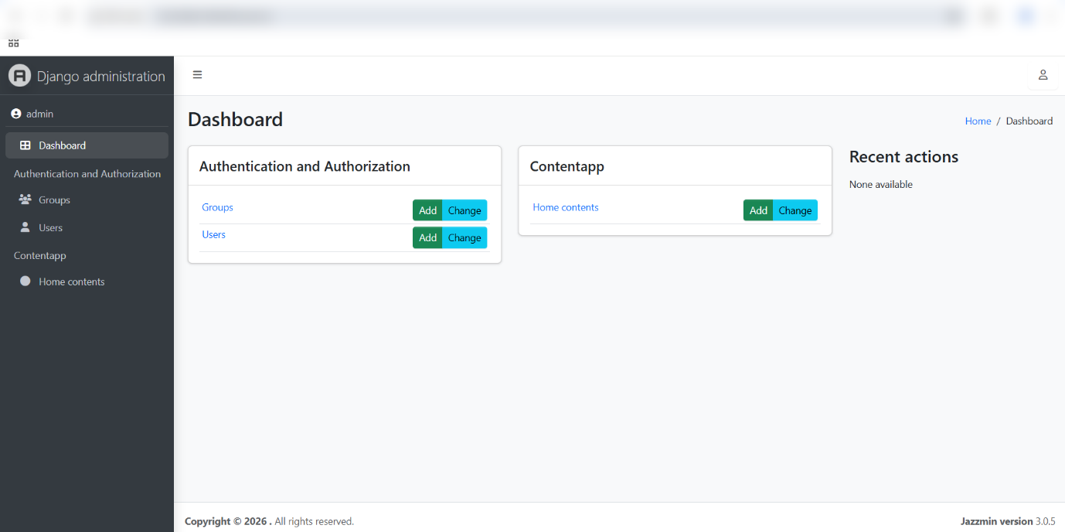
Django deployed homepage

Django deployed content


